**Project Task: Week 1**

**1. Identifying Stakeholders**

**List of Stakeholders:**

* **Project Sponsor:** Senior executive overseeing the project.
* **Product Owner:** Person responsible for the product vision and prioritizing the backlog.
* **Business Analysts:** Team members responsible for capturing requirements and documenting them.
* **Development Team:** Engineers and developers who will build the feature.
* **UX/UI Designers:** Designers responsible for the user interface and experience.
* **Marketing Team:** Members who will handle advertising and promotions.
* **Operations Team:** Team handling the logistics and delivery operations.
* **Customer Support:** Team addressing customer queries and issues.
* **End Users:** Customers using the ABC Pantry feature.
* **Legal and Compliance:** Ensures the feature complies with regulations

**Future Scope**

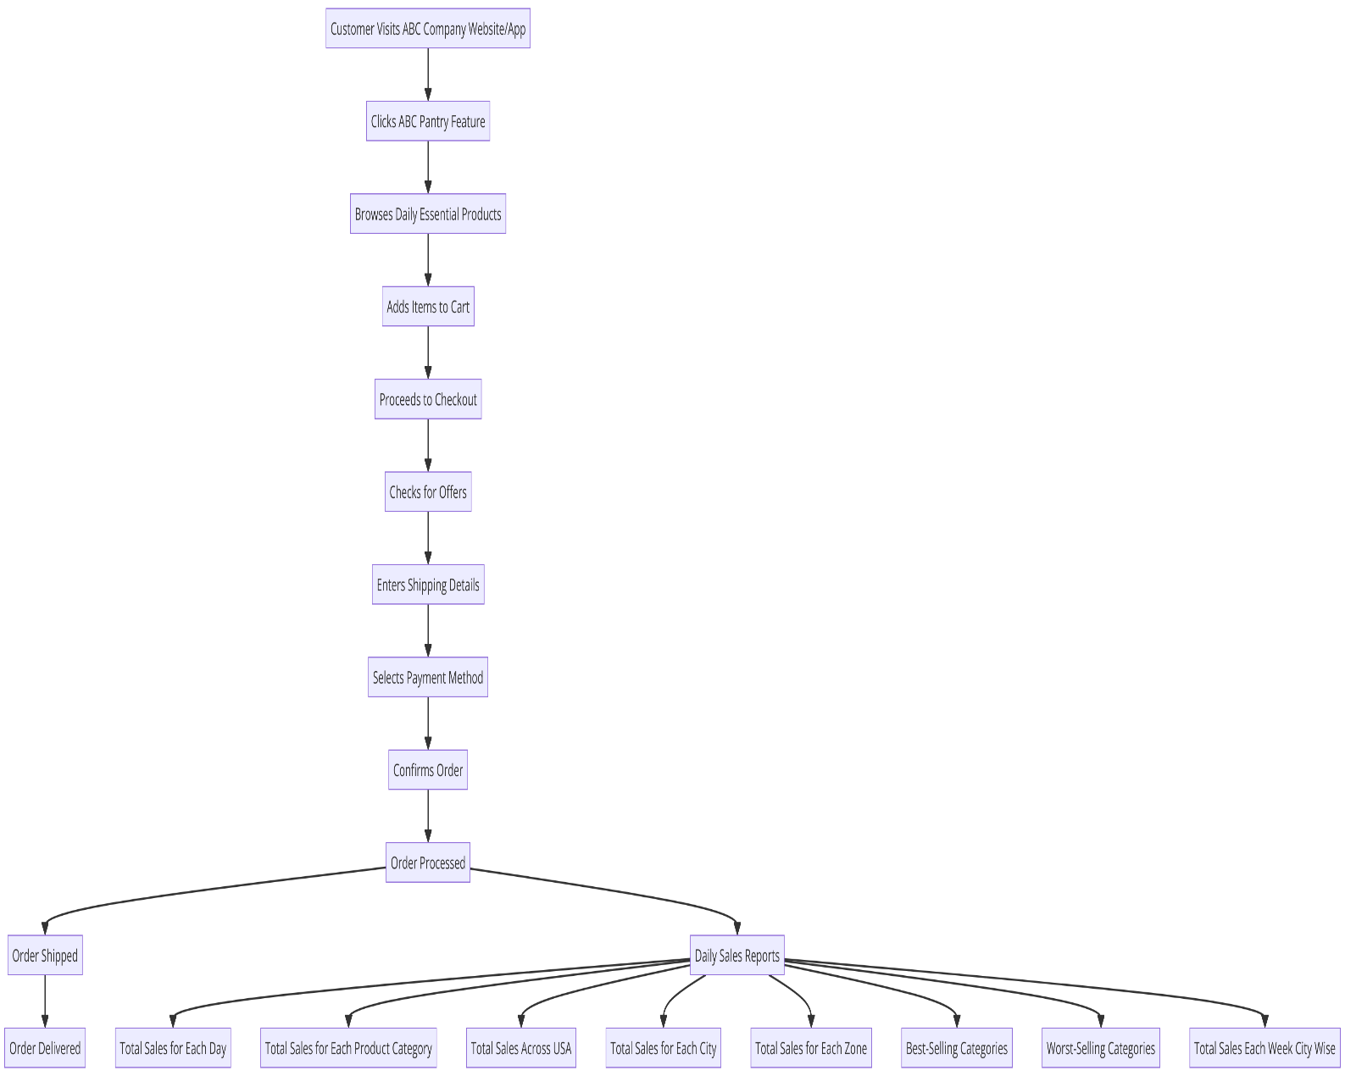

**Current Sate**

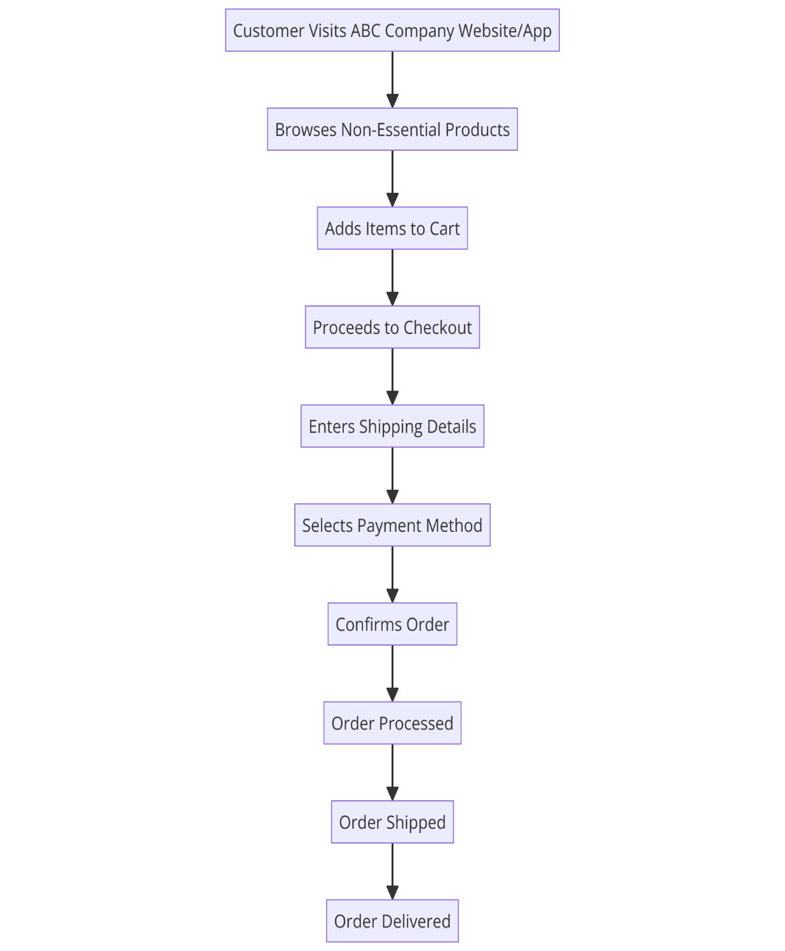

**3. Scope of the Feature ABC Pantry**

**Main Features to be Developed:**

1. **ABC Pantry Feature Integration**: Integrate the ABC Pantry feature prominently in the website/app.
2. **Product Categories**: Logical grouping of daily essential products into categories.
3. **Advertisement Integration**: Display non-intrusive advertisements.
4. **Special Offers**: Display offers and discounts.
5. **Shopping Cart Integration**: Ability to add items to the shopping cart.
6. **Order Value Validation**: Ensure order value exceeds 30 USD.
7. **Free Delivery Validation**: Ensure free delivery for orders above 50 USD.
8. **City Presence**: Restrict availability to specific cities.
9. **Sales Reporting**: Generate various sales reports.

**4. In-Scope and Out-of-Scope Items**

**In-Scope:**

1. Adding the ABC Pantry feature to the website/app.
2. Creating new product categories for daily essentials.
3. Integrating advertisements and special offers.
4. Ensuring the shopping cart can handle ABC Pantry and non-essential items.
5. Implementing minimum order value and free delivery conditions.
6. Limiting ABC Pantry availability to specific cities.
7. Generating daily sales reports.

**Out-of-Scope:**

1. Changes to non-essential product categories.
2. Enhancements unrelated to ABC Pantry.
3. International expansion beyond specified cities.
4. Major redesigns of the website/app unrelated to ABC Pantry.

**5. Business Requirements**

**Functional Requirements:**

1. **Feature Integration**: ABC Pantry should be prominently visible and accessible.
2. **Product Categorization**: Logical grouping of daily essential products.
3. **Advertisement Display**: Show five non-intrusive advertisements.
4. **Offer Display**: Display special offers.
5. **Shopping Cart**: Allow adding items to the shopping cart.
6. **Order Validation**: Ensure the total order value is above 30 USD.
7. **Free Delivery**: Offer free delivery for orders above 50 USD.
8. **City Restriction**: Limit ABC Pantry availability to specified cities.

**Non-Functional Requirements:**

1. **Performance**: The website/app should handle increased traffic and load efficiently.
2. **Usability**: The feature should be easy to use and navigate.
3. **Security**: Ensure secure handling of user data and transactions.
4. **Scalability**: The system should support future expansion to more cities or additional features.
5. **Reliability**: Ensure high availability and minimal downtime.
6. **Draw Wireframes or Mock Screens**

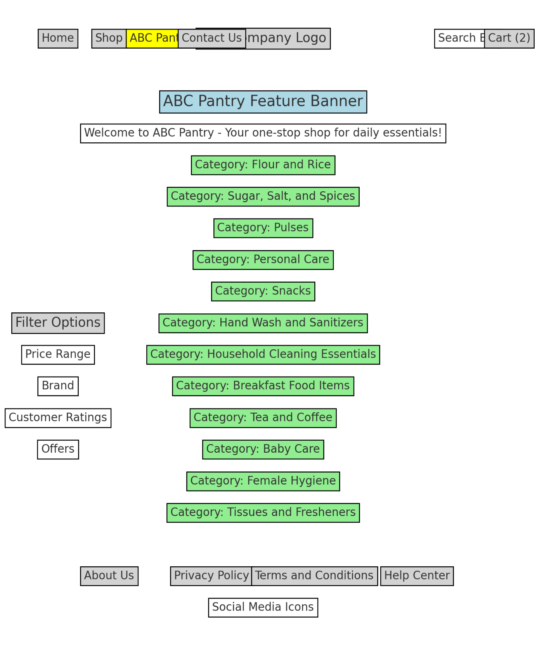

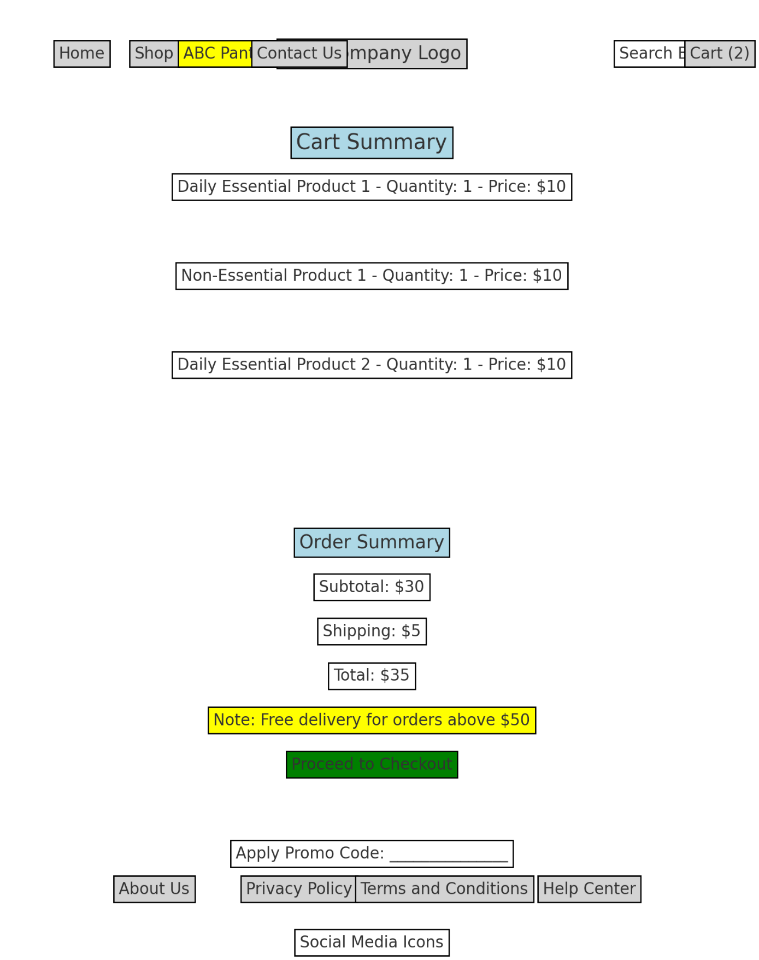

**Product Backlog of User Stories: -**

**User Story 1: ABC Pantry Feature Integration**

* **Story:** As a user, I want to see the ABC Pantry feature prominently on the home page so that I can easily access daily essential products.
* **Acceptance Criteria:**
  1. The ABC Pantry feature is visible on the home page.
  2. The feature is accessible from both the website and the app.
  3. The feature is placed in a prominent area that is easily noticeable by users.

**User Story 2: Product Categorization**

* **Story:** As a user, I want to browse daily essential products in logically grouped categories so that I can find the products I need quickly.
* **Acceptance Criteria:**
  1. The categories include Flour and Rice, Sugar, Salt, and Spices, Pulses, Personal Care, Snacks, Hand Wash and Sanitizers, Household Cleaning Essentials, Breakfast Food Items, Tea and Coffee, Baby Care, Female Hygiene, Tissues and Fresheners.
  2. Each category is displayed clearly with relevant products listed.
  3. Users can easily navigate between categories.

**User Story 3: Advertisement Integration**

* **Story:** As a user, I want to see non-intrusive advertisements while browsing ABC Pantry so that my shopping experience is not spoiled.
* **Acceptance Criteria:**
  1. A maximum of five advertisements are displayed.
  2. Advertisements do not interfere with the browsing experience.
  3. Advertisements are relevant to the user's interests and shopping history**.**

**User Story 4: Special Offers Display**

* **Story:** As a user, I want to see special offers on daily essential products so that I can take advantage of discounts**.**
* **Acceptance Criteria:**
  1. Special offers are clearly displayed on the ABC Pantry home page and relevant category pages.
  2. Offers are updated regularly.
  3. Users can easily add discounted products to their cart.

**User Story 5: Shopping Cart Integration**

* **Story:** As a user, I want to add daily essential products to my shopping cart so that I can purchase them along with non-essential products.
* **Acceptance Criteria:**
  1. Users can add products from both ABC Pantry and other categories to their cart.
  2. The cart displays all selected items with their respective categories.
  3. Users can remove items or change quantities from the cart**.**

**User Story 6: Minimum Order Value Validation**

* **Story:** As a user, I want the system to enforce a minimum order value of 30 USD so that my order meets the required conditions for checkout.
* **Acceptance Criteria:**
  1. The system checks the total order value before allowing checkout.
  2. Users are notified if their order does not meet the minimum value of 30 USD.
  3. Users cannot proceed to payment if the minimum order value is not met.

**User Story 7: Free Delivery Validation**

* **Story:** As a user, I want free delivery for orders above 50 USD so that I can save on shipping costs.
* **Acceptance Criteria:**
  1. The system checks the total order value for free delivery eligibility.
  2. Users are notified if they qualify for free delivery.
  3. Free delivery is applied to eligible orders during checkout.

**User Story 8: City Presence Restriction**

* **Story:** As a user, I want ABC Pantry to be available only in certain cities so that the feature is relevant to my location.
* **Acceptance Criteria:**
  1. ABC Pantry is accessible only in specified cities.
  2. Users outside these cities are notified that the feature is not available in their area.
  3. The system verifies user location during the browsing session.

**User Story 9: Sales Reporting**

* **Story:** As a manager, I want to generate sales reports so that I can analyze daily, weekly, and category-wise performance**.**
* **Acceptance Criteria:**
  1. Reports include total sales for each day.
  2. Reports show sales for each product category.
  3. Reports provide sales data for each city and zone.
  4. Reports identify best-selling and worst-selling categories.
  5. Reports highlight the highest booking day of the week.

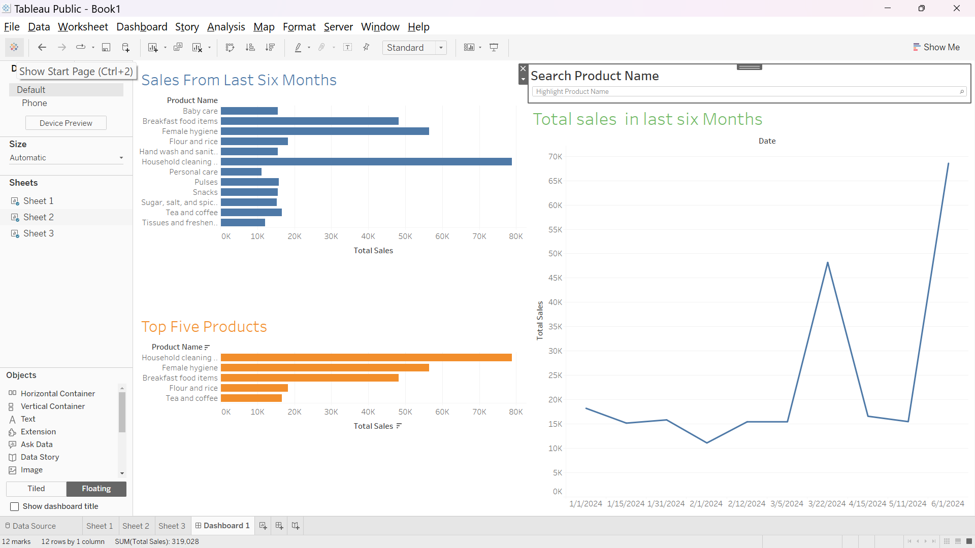

**Questions -1 for excel**

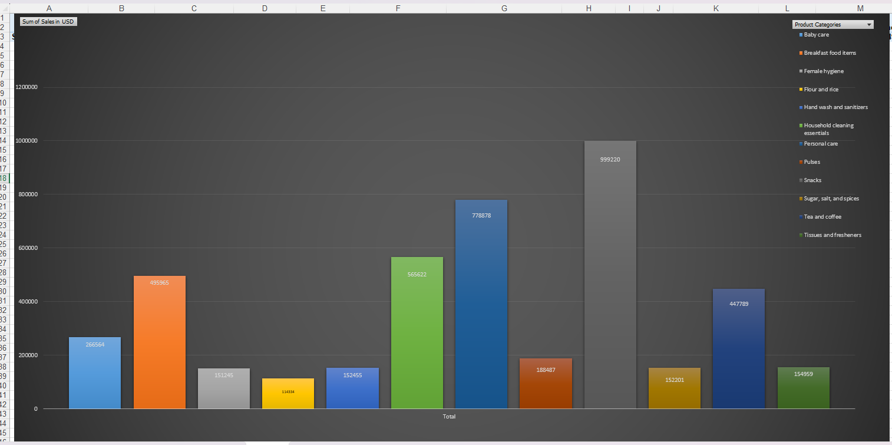

**Descending Order:-**

**Ascending order.**

**Question 2:**

Question 3:

|  |  |  |  |  |
| --- | --- | --- | --- | --- |
|  |  |  |  |  |

